UNIT – V

BRANCH AND BOUND -- THE METHOD

The design technique known as branch and bound is very similar to backtracking (seen in unit 4) in that it searches a tree model of the solution space and is applicable to a wide variety of discrete combinatorial problems.

Each node in the combinatorial tree generated in the last Unit defines a problem state. All paths from the root to other nodes define the state space of the problem.

Solution states are those problem states 's' for which the path from the root to 's' defines a tuple in the solution space. The leaf nodes in the combinatorial tree are the solution states.

Answer states are those solution states 's' for which the path from the root to 's' defines a tuple that is a member of the set of solutions (i.e.,it satisfies the implicit constraints) of the problem.

The tree organization of the solution space is referred to as the state space tree.

A node which has been generated and all of whose children have not yet been generated is called a live node.

The live node whose children are currently being generated is called the E-node (node being expanded).

A dead node is a generated node, which is not to be expanded further or all of whose children have been generated.

Bounding functions are used to kill live nodes without generating all their children.

Depth first node generation with bounding function is called backtracking. State generation methods in which the E-node remains the E-node until it is dead lead to branch-and-bound method.

The term branch-and-bound refers to all state space search methods in which all children of the E-node are generated before any other live node can become the E-node.

In branch-and-bound terminology breadth first search(BFS)- like state space search will be called FIFO (First In First Output) search as the list of live nodes is a first -in-first -out list(or queue).

A D-search (depth search) state space search will be called LIFO (Last In First Out) search, as the list of live nodes is a list-in-first-out list (or stack).

Bounding functions are used to help avoid the generation of sub trees that do not contain an answer node.

The branch-and-bound algorithms search a tree model of the solution space to get the solution. However, this type of algorithms is oriented more toward optimization. An algorithm of this type specifies a real -valued cost function for each of the nodes that appear in the search tree.

Usually, the goal here is to find a configuration for which the cost function is minimized. The branch-and-bound algorithms are rarely simple. They tend to be quite complicated in many cases.

Example 8.1[4-queens] Let us see how a FIFO branch-and-bound algorithm would search the state space tree (figure 7.2) for the 4-queens problem.
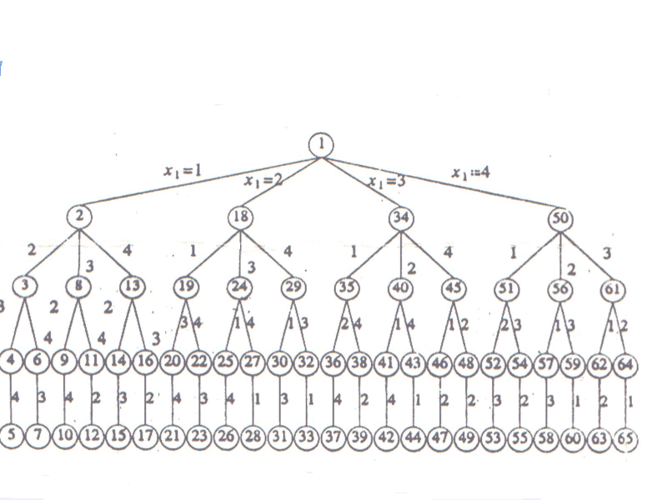

Initially, there is only one live node, node1. This represents the case in which no queen has been placed on the chessboard. This node becomes the E-node.

It is expanded and its children, nodes2, 18, 34 and 50 are generated.

These nodes represent a chessboard with queen1 in row 1and columns 1, 2, 3, and 4 respectively.

The only live nodes 2, 18, 34, and 50.If the nodes are generated in this order, then the next E-node are node 2.

It is expanded and the nodes 3, 8, and 13 are generated. Node 3 is immediately killed using the bounding function. Nodes 8 and 13 are added to the queue of live nodes.

Node 18 becomes the next E-node. Nodes 19, 24, and 29 are generated. Nodes 19 and 24 are killed as a result of the bounding functions. Node 29 is added to the queue of live nodes.

Now the E-node is node 34.Figure 8.1 shows the portion of the tree of Figure 7.2 that is generated by a FIFO branch-and-bound search. Nodes that are killed as a result of the bounding functions are a "B" under them.

Numbers inside the nodes correspond to the numbers in Figure 7.2.Numbers outside the nodes give the order in which the nodes are generated by FIFO branch-and-bound.

At the time the answer node, node 31, is reached, the only live nodes remaining are nodes 38 and 54.

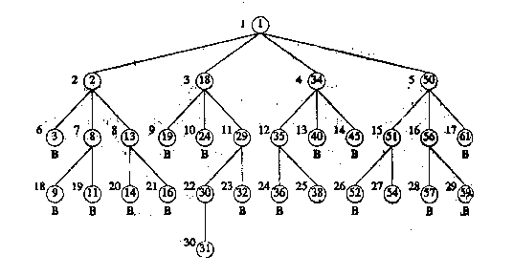

Least Cost (LC) Search:

In both LIFO and FIFO branch-and-bound the selection rule for the next E-node is rather rigid and in a sense blind. The selection rule for the next E-node does not give any preference to a node that has a very good chance of getting the search to an answer node quickly.

Thus, in Example 8.1, when node 30 is generated, it should have become obvious to the search algorithm that this node will lead to answer node in one move. However, the rigid FIFO rule first requires the expansion of all live nodes generated before node 30 was expanded.

The search for an answer node can often be speeded by using an "intelligent" ranking function (.) for live nodes. The next E-node is selected on the basis of this ranking function.

If in the 4-queens example we use a ranking function that assigns node 30 a better rank than all other live nodes, then node 30 will become E-node, following node 29.The remaining live nodes will never become E-nodes as the expansion of node 30 results in the generation of an answer node (node 31).

The ideal way to assign ranks would be on the basis of the additional computational effort (or cost) needed to reach an answer node from the live node. For any node x, this cost could be

(1) The number of nodes on the sub-tree x that need to be generated before any answer node is generated or, more simply,

(2) The number of levels the nearest answer node (in the sub-tree x) is from x

Using cost measure (2), the cost of the root of the tree of Figure 8.1 is 4 (node 31 is four levels from node 1).The costs of nodes 18 and 34,29 and 35,and 30 and 38 are respectively 3, 2, and 1.The costs of all remaining nodes on levels 2, 3, and 4 are respectively greater than 3, 2, and 1.

Using these costs as a basis to select the next E-node, the E-nodes are nodes 1, 18, 29, and 30 (in that order).The only other nodes to get generated are nodes 2, 34, 50, 19, 24, 32, and 31.

The difficulty of using the ideal cost function is that computing the cost of a node usually involves a search of the sub-tree x for an answer node. Hence, by the time the cost of a node is determined, that sub-tree has been searched and there is no need to explore x again. For this reason, search algorithms usually rank nodes only based on an estimate (.) of their cost.

Let (x) be an estimate of the additional effort needed to reach an answer node from x. node x is assigned a rank using a function (.) such that(x) =f (h(x)) + (x), where h(x) is the cost of reaching x from the root and f(.) is any non-decreasing function.

A search strategy that uses a cost function (x) =f (h(x)) + (x), to select the next e-node would always choose for its next e-node a live node with least (.).Hence, such a strategy is called an LC-search (least cost search).

Cost function c (.) is defined as, if x is an answer node, then c(x) is the cost (level, computational difficulty, etc.) of reaching x from the root of the state space tree. If x is not an answer node, then c(x) =infinity, providing the sub-tree x contains no answer node; otherwise c(x) is equals the cost of a minimum cost answer node in the sub-tree x.

It should be easy to see that (.) with f (h(x)) =h(x) is an approximation to c (.). From now on (x) is referred to as the cost of x.

Bounding:

A branch -and-bound searches the state space tree using any search mechanism in which all the children of the E-node are generated before another node becomes the E-node.

We assume that each answer node x has a cost c(x) associated with it and that a minimum-cost answer node is to be found. Three common search strategies are FIFO, LIFO, and LC.

A cost function (.) such that(x) <=c(x) is used to provide lower bounds on solutions obtainable from any node x. If upper is an upper bound on the cost of a minimum-cost solution, then all live nodes x with (x)>upper may be killed as all answer nodes reachable from x have cost c(x)>=(x)>upper. The starting value for upper can be set to infinity.

Clearly, so long as the initial value for upper is no less than the cost of a minimum-cost answer node, the above rule to kill live nodes will not result in the killing of a live node that can reach a minimum-cost answer node .Each time a new answer is found ,the value of upper can be updated.

As an example optimization problem, consider the problem of job scheduling with deadlines. We generalize this problem to allow jobs with different processing times. We are given n jobs and one processor. Each job i has associated with it a three tuple
( ).job i requires units of processing time .if its processing is not completed by the deadline, and then a penalty is incurred.

The objective is to select a subset j of the n jobs such that all jobs in j can be completed by their deadlines. Hence, a penalty can be incurred only on those jobs not in j. The subset j should be such that the penalty incurred is minimum among all possible subsets j. such a j is optimal.

Consider the following instances: n=4,(, , )=(5,1,1),( , , )=(10,3,2),( ,, )=(6,2,1),and(, , )=(3,1,1).The solution space for this instances consists of all possible subsets of the job index set{1,2,3,4}. The solution space can be organized into a tree by means of either of the two formulations used for the sum of subsets problem.
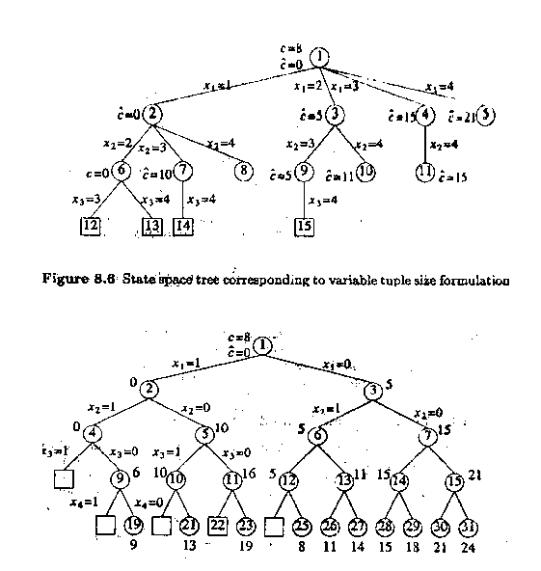
Figure 8.7

Figure 8.6 corresponds to the variable tuple size formulations while figure 8.7 corresponds to the fixed tuple size formulation. In both figures square nodes represent infeasible subsets. In figure 8.6 all non-square nodes are answer nodes. Node 9 represents an optimal solution and is the only minimum-cost answer node .For this node j= {2,3} and the penalty (cost) is 8. In figure 8.7 only non-square leaf nodes are answer nodes. Node 25 represents the optimal solution and is also a minimum-cost answer node. This node corresponds to j={2,3} and a penalty of 8. The costs of the answer nodes of figure 8.7 are given below the nodes.

TRAVELLING SALESMAN PROBLEM

INTRODUCTION:

It is algorithmic procedures similar to backtracking in which a new branch is chosen and is there (bound there) until new branch is choosing for advancing.

This technique is implemented in the traveling salesman problem [TSP] which are asymmetric (Cij <>Cij) where this technique is an effective procedure.

STEPS INVOLVED IN THIS PROCEDURE ARE AS FOLLOWS:

STEP 0: Generate cost matrix C [for the given graph g]

STEP 1: [ROW REDUCTION]
For all rows do step 2

STEP: Find least cost in a row and negate it with rest of the
elements.

STEP 3: [COLUMN REDUCTION]
Use cost matrix- Row reduced one for all columns do STEP 4.

STEP 4: Find least cost in a column and negate it with rest of the elements.

STEP 5: Preserve cost matrix C [which row reduced first and then column reduced] for the i ^{th} time.

STEP 6: Enlist all edges (i, j) having cost = 0.

STEP 7: Calculate effective cost of the edges. (i, j)=least cost in the i ^{th} row excluding (i, j) + least cost in the j ^{th} column excluding (i, j).

STEP 8: Compare all effective cost and pick up the largest l. If two or more have same cost then arbitrarily choose any one among them.

STEP 9: Delete (i, j) means delete i^{th} row and j^{th} column change (j, i) value to infinity. (Used to avoid infinite loop formation) If (i,j) not present, leave it.

STEP 10: Repeat step 1 to step 9 until the resultant cost matrix having order of 2*2 and reduce it. (Both R.R and C.C)

STEP 11: Use preserved cost matrix Cn, Cn-1… C1
Choose an edge [i, j] having value =0, at the first time for a preserved matrix and leave that matrix.

STEP 12: Use result obtained in Step 11 to generate a complete tour.

EXAMPLE: Given graph G

22 5
1
27 25
9 19
25
5
2
8
1
50
10 31 17 15
6 40
30
4
3
7
6
24

MATRIX:

1 2 3 4 5
α | 25 | 40 | 31 | 27
5 | α | 17 | 30 | 25
19 | 15 | α | 6 | 1
9 | 50 | 24 | α | 6
22 | 8 | 7 | 10 | α
1

2

3

4

5

PHASE I

STEP 1: Row Reduction C

C1 [ROW REDUCTION:

1 2 3 4 5
α | 0 | 15 | 6 | 2
0 | α | 12 | 25 | 20
18 | 14 | α | 5 | 0
3 | 44 | 18 | α | 0
15 | 1 | 0 | 3 | α
1

2

3

4

5

STEP 3: C1 [Column Reduction]

1 2 3 4 5
α | 0 | 15 | 3 | 2
0 | α | 12 | 25 | 20
18 | 14 | α | 2 | 0
3 | 44 | 18 | α | 0
15 | 1 | 0 | 3 | α
1

2

3

4

5

STEP 5:
Preserve the above in C1,

1 2 3 4 5
α | 0 | 15 | 3 | 2
0 | α | 12 | 22 | 20
18 | 14 | α | 2 | 0
3 | 44 | 18 | α | 0
15 | 1 | 0 | 3 | α
1

2

3

4

5

STEP 6:

L=

STEP 7:
Calculation of effective cost [E.C]
(1,2) = 2+1 =3
(2,1) = 12+3 = 15
(3,5) = 2+0 =2
(4,5) = 3+0 = 3
(5,3) = 0+12 = 12
(5,4) = 0+2 = 2

STEP 8:
L having edge (2,1) is the largest.

STEP 9: Delete (2,1) from C1 and make change in it as (1,2) → α if exists.

Now Cost Matrix =
2 3 4 5
α | 15 | 3 | 2
14 | α | 2 | 0
44 | 18 | α | 0
1 | 0 | 0 | α
1

3

4

5

STEP 10: The Cost matrix 2 x 2.
Therefore, go to step 1.

PHASE II:

STEP1: C2(R, R)
2 3 4 5
1
α | 13 | 1 | 0
14 | α | 2 | 0
44 | 18 | α | 0
1 | 0 | 0 | α

3

4

5

STEP 3: C2 (C, R)

2 3 4 5
1
α | 13 | 1 | 0
13 | α | 2 | 0
43 | 18 | α | 0
0 | 0 | 0 | α

3

4

5

STEP 5: Preserve the above in C2

C2 =
2 3 4 5
1
α | 13 | 1 | 0
13 | α | 2 | 0
43 | 18 | α | 0
0 | 0 | 0 | α

3

4

5

STEP 6:

L= {(1,5), (3,5), (4,5), (5,2), (5,3), (5,4)}

STEP 7: calculation of E.C.

(1,5) = 1+0 =1
(3,5) = 2+0 =2
(4,5) = 18+0 =18
(5,2) = 0+13 =13
(5,3) = 0+13 =13
(5,4) = 0+1 =1

STEP 8: L having an edge (4,5) is the largest.

STEP 9: Delete (4,5) from C2 and make change in it as (5,4) = α
if exists.

Now, cost matrix

2 3 4
1
α | 13 | 1
13 | α | 2
0 | 0 | α

3

5

STEP 10: THE cost matrix 2x2 hence go to step 1

PHASE III:

STEP 1: C3 (R, R)

2 3 4
1
α | 12 | 0
11 | α | 0
0 | 0 | α

3

5

STEP 3: C3 (C, R)

2 3 4
1
α | 12 | 0
11 | α | 0
0 | 0 | α
3
5

STEP 5: preserve the above in C2

STEP 6: L={(1,4), (3,4), (5,2), (5,3)}

STEP 7: calculation of E.C
(1,4)=12+0=12
(3,4)=11+0=11
(5,2)=0+11=11
(5,3)=0+12=12

STEP 8: Here we are having two edges (1,4) and (5,3) with cost = 12. Hence arbitrarily choose (1,4)

STEP 9: Delete (i,j) →(1,4) and make change in it (4,1) = α if exists.

Now cost matrix is

2 3
11 | α
0 | 0
2
3

STEP 10: We have got 2x2 matrix

C4 (RR)=
2 3
0 | α
0 | 0
3
5

C4 (C, R) =
2 3
0 | α
0 | 0
3
5

Therefore,C4 = 2 3
0 | α
0 | 0
3
5

STEP 11: LIST C1, C2, C3 AND C4

C4 2 3
3
0 | α
0 | 0
5

C3 2 3 4
1
α | 12 | 0
11 | α | 0
0 | 0 | α
3
5

C2 =

1
α | 13 | 1 | 0
13 | α | 2 | 0
43 | 18 | α | 0
0 | 0 | 0 | α
3
4
5

C1 =
1 2 3 4 5
1
α | 0 | 15 | 3 | 2
0 | α | 12 | 22 | 20
18 | 14 | α | 2 | 0
3 | 44 | 18 | α | 0
15 | 1 | 0 | 0 | α
2
3
4
5

STEP 12:
- Use C4 =

2 3
0 | α
0 | 0
3
5

Pick up an edge (I, j) =0 having least index

Here (3,2) =0

Hence, T← (3,2)

Use C3 =
2 3 4
1
α | 12 | 0
11 | α | 0
0 | 0 | α
3
5

Pick up an edge (i, j) =0 having least index

Here (1,4) =0

Hence, T←(3,2), (1,4)

Use C2=
2 3 4 5
1
α | 13 | 1 | 0
13 | α | 2 | 0
43 | 18 | α | 0
0 | 0 | 0 | α

3

4

5

Pick up an edge (i, j) with least cost index.

Here (1,5) → not possible because already chosen index i (i=j)
(3,5) → not possible as already chosen index.
(4,5) →0

Hence, T← (3,2), (1,4), (4,5)

Use C1 =

1 2 3 4 5
1
α | 0 | 15 | 3 | 2
0 | α | 12 | 22 | 20
18 | 14 | α | 2 | 0
3 | 44 | 18 | α | 0
15 | 1 | 0 | 0 | α
2
3
4
5

Pick up an edge (i, j) with least index

(1,2) → Not possible
(2,1) → Choose it
HENCE T← (3,2), (1,4), (4,5), (2,1)

SOLUTION:

From the above list
3—2—1—4—5
This result now, we have to return to the same city where we started (Here 3).

Final result:
3—2—1—4—5—3

Cost is 15+15+31+6+7=64

